## Patient Medical Record

**Patient Name:** Jane Doe

**Date of Birth:** 01/01/1980

**Patient ID:** 1234567

**Date of Report:** 2023-12-19

**Referring Physician:** Dr. John Smith, MD

**Reason for Referral:** Evaluation of persistent headaches and dizziness.

**History of Present Illness:**

The patient is a 43-year-old female presenting with a 3-month history of intermittent headaches described as throbbing in nature, primarily located in the frontal and temporal regions. The headaches are typically moderate in intensity but occasionally severe, lasting several hours. She also reports episodes of dizziness, which she describes as a feeling of lightheadedness, occurring 2-3 times per week. These episodes are not associated with changes in position and typically last a few minutes.

**XRAY-Scan:** 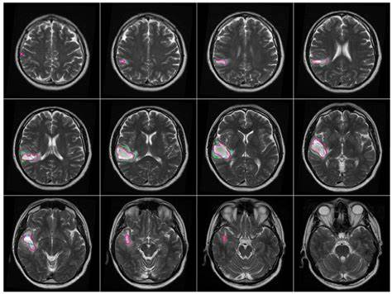

**Past Medical History:**

- Seasonal allergies

- Mild asthma, well-controlled with an albuterol inhaler (as needed)

**Surgical History:**

- Appendectomy (age 12)

**Medications:**

- Loratadine 10mg daily (for allergies)

- Albuterol inhaler (as needed for asthma)

**Allergies:**

- Penicillin (rash)

**Family History:**

- Mother: Hypertension, type 2 diabetes

- Father: History of heart attack (age 60)

**Social History:**

- Patient is a non-smoker.

- Drinks alcohol occasionally (1-2 drinks per week).

- Works as a graphic designer.

**Review of Systems:**

- Constitutional: Denies fever, chills, weight loss, or fatigue.

- Neurological: Reports headaches and dizziness as described above. Denies any other neurological symptoms.

- Respiratory: Reports mild asthma, well-controlled.

- Cardiovascular: Denies chest pain, palpitations, or shortness of breath.

**Physical Examination:**

- Vital Signs: Blood pressure 120/80 mmHg, heart rate 72 bpm, respiratory rate 16 breaths/min, temperature 98.6°F (37°C).

- General: Patient is alert and oriented, in no acute distress.

- Neurological: Cranial nerves II-XII intact. Normal gait and coordination. No focal neurological deficits.

**Assessment:**

- Headaches, unspecified

- Dizziness, unspecified

**Plan:**

- Order a complete blood count (CBC) and metabolic panel.

- Schedule a brain MRI to rule out any underlying structural abnormalities.

- Prescribe a trial of a daily prophylactic medication for headaches (e.g., topiramate).

- Recommend lifestyle modifications, including stress management techniques and regular exercise.

- Follow-up appointment in 4 weeks to review test results and assess response to treatment.

**Physician Signature:**

(Electronic Signature)

---

**Important Notes:**

- **This is a fictional example for illustrative purposes only.** It is not a real medical record and should not be used for any medical decisions or advice.

- **Real medical records contain much more detailed information** and are subject to strict privacy regulations (HIPAA in the US).

- **Specific content and formatting of medical records vary** depending on the healthcare provider, specialty, and local regulations.